**MONTESSORI HIGH SCHOOL**

**Slip Test – 1**

**Class: 9th Sub: Mathematics Max. Marks: 20**

**Answer the following questions 4 × 2 = 8M**

1. Find the value of ‘x’ in the following figure?

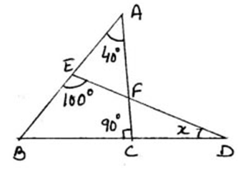

1. If an angle is 200 less than twice to its supplementary angle, then find the angles?
2. In ∆ABC, the bisectors of ∠B and ∠C intersect at ‘O’. If ∠A = 1300, then find ∠BOC?
3. Draw a diagram to the following data?

“It is given that in ∆PAE, angle A is right angle. https://whatis.techtarget.com/WhatIs/images/angl-sym.gifP = y0 and https://whatis.techtarget.com/WhatIs/images/angl-sym.gifAEP = 700. AE is produced to B. EC is bisector of https://whatis.techtarget.com/WhatIs/images/angl-sym.gifPEB. CD is parallel to EB and https://whatis.techtarget.com/WhatIs/images/angl-sym.gifECD = x0.”

**Rewrite the solutions by filling the blanks (?) with correct answers 3 × 2 = 6M**

1. **Prove that the sum of all exterior angles of a triangle is 33600?**

**Sol:**-

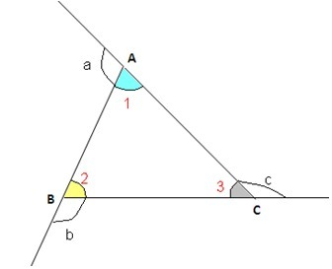

Given: In ∆ABC, ∠1, ∠2 and ∠3 are ? angles.

And ∠a, ∠b and ∠c are ? angles.

R.T.P : ∠a + ∠b + ∠c = ?

Proof: from the diagram,

∠1 + ? = 1800 ( ? )

? + ∠b = ? ( ? )

∠3 + ∠c = 1800 ( ? )

by adding the three equations, we will get

∠1 + ? + ? + ∠b + ∠3 + ∠c = 5400

(∠1 + ? + ?) + ( ? + ? + ∠c) = 5400

1800 + ( ? + ? + ∠c) = 5400

? + ? + ∠c = 5400 - ?

? + ? + ∠c = ?

Hence proved.

1. **It is given that $m∥n$. To prove ∠3 is equal to ∠5, write reasons for the** **given statements.**

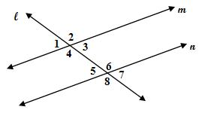

Statement Reasons

i) $m∥n$. ?

ii) ∠3 = ∠1 ?

iii) ∠1 = ∠5 ?

iv) ∠3 = ∠5 ?

1. **In ∆ABC, if ∠A - ∠B = 150 and ∠B - ∠C = 300, then find the measure of the angles?**

**Sol**:-

Given in ∆ABC,

∠A - ∠B = 150

∠A = 150 + ?

And ∠B - ∠C = 300

⇒ ∠B = 300 + ?

∠A = ? + ?

but we know that

∠A + ∠B + ∠C = 1800

? + ? + 300 + ? + ∠C = 1800

750 + 3∠C = 1800

3∠C = 1800 – 750

3∠C = ?

∠C = ?

∠A = ? + ? = ?

∠B = ? + ? = ?

**In the following questions, we gave some mistakes. Identify them and re-write the solution by correcting the mistakes.** 2 × 3 = 6M

1. **Find the values of ‘x’ and ‘y’ from the figure if AB∥CD ∥EF?**

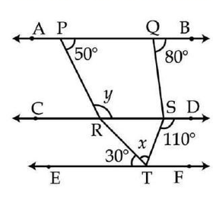

**Sol**:- from the diagram,

AB is parallel to CD and PR is transversal

So y = 500 (co-interior angles) _________ (1)

CD is parallel to EF and ST is transversal

So ∠STF + 1100 = 1800 (Alternate interior angles)

∠STF = 1800 -1100 = 700

CD is parallel to EF and RT is transversal

So x + ∠STF = y + ∠RTE

x + 700 = 500 + 300 (from 1)

x = 800 – 700

x = 100

1. **For what value of ‘x’ the lines l and m will be parallel?**

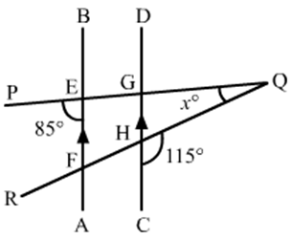

**Sol**:- from the diagram,

∠GEF = 950 (linear pair)

∠EFH = 1050 (co-interior angles)

We know that

Sum of the three angles of a triangle is 1800

∠EFH + ∠GEF + ∠Q = 1800 (in ∆QEF)

1050 + 950 + x = 1800

2000 + x = 1800

x = 2000 – 1800

x = 200.